Examples of Functional Inspection Results

Thermal(thermal-37)
The thermal camera was utilized to monitor the surface temperature of the motor. The test results indicate that the motor's operating temperature is within the normal range.

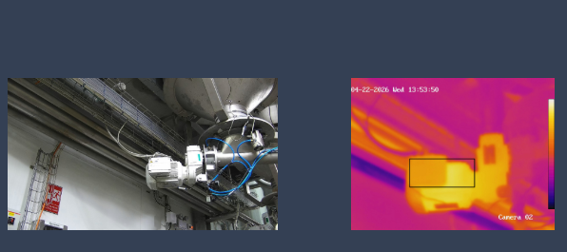
Sample Inspection Results
inspection details
Inspection Index:3
Mission Id:266
Max Temperature:36.9
Min Temperature:35.6
Notification Level:Pass

Air leak(leakage-15)
The Acoustic Imager successfully detected and localized an air leak, pinpointing its exact coordinates as shown in the visual overlay.
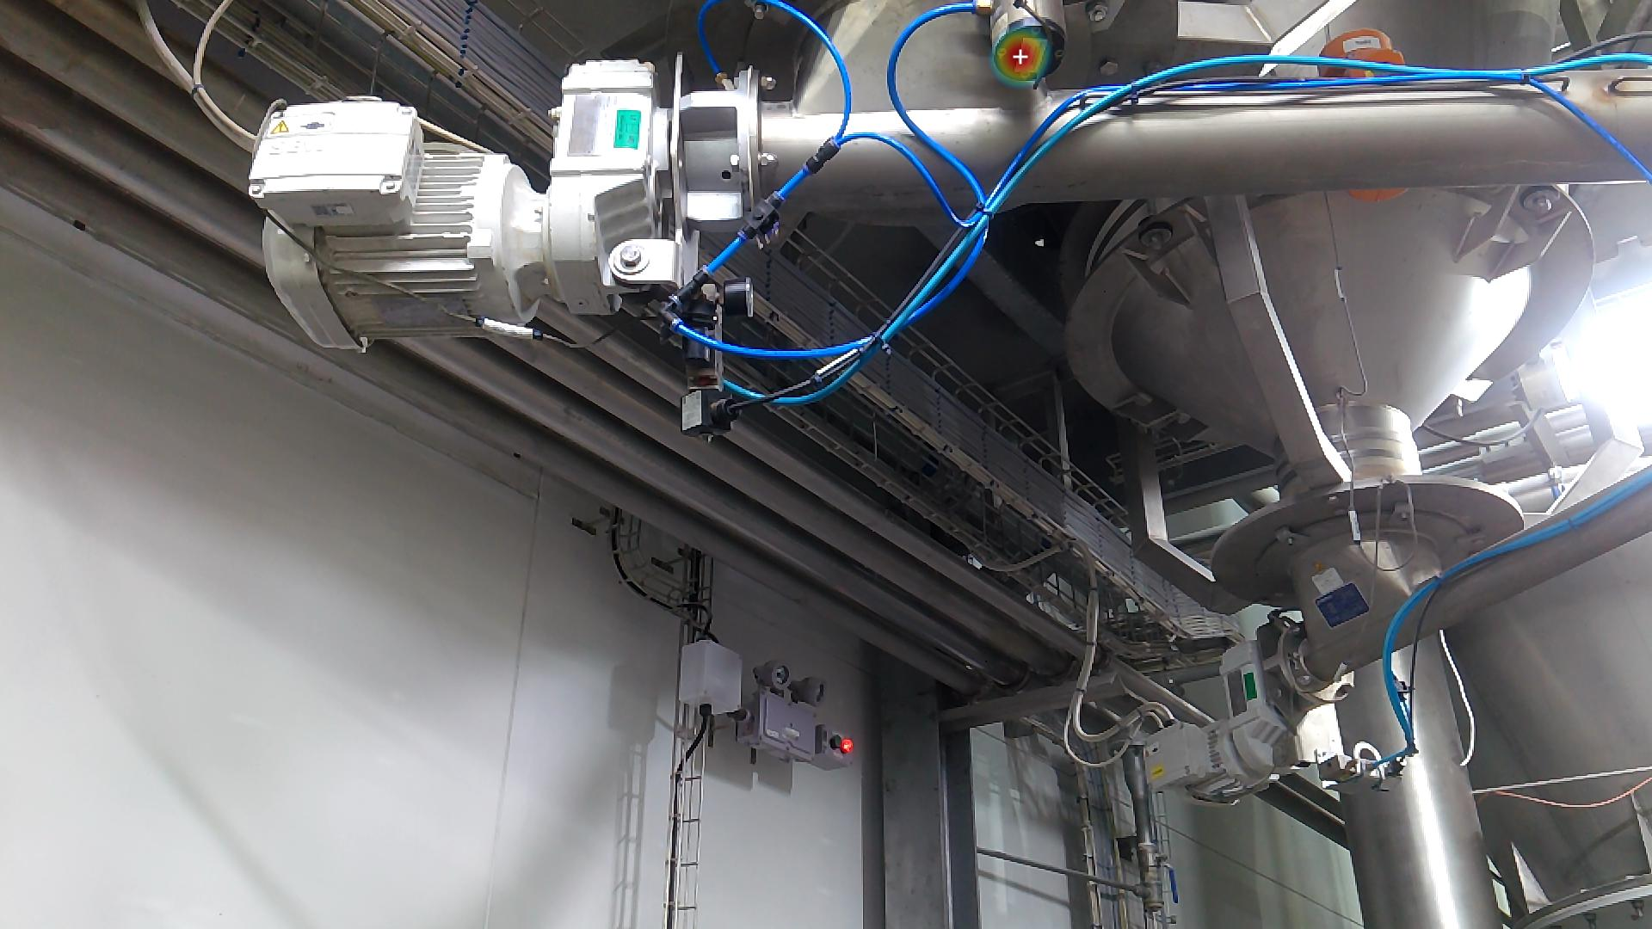
Sample Inspection Results
inspection details
Inspection Index:6
Mission Id:269
Is Leak:True
Notification Level:Critical

analog gauge detection
Due to the absence of color-coded bands (green/red) on the gauge to indicate the safe operating range, the system could not evaluate the status, resulting in an inspection output of False.
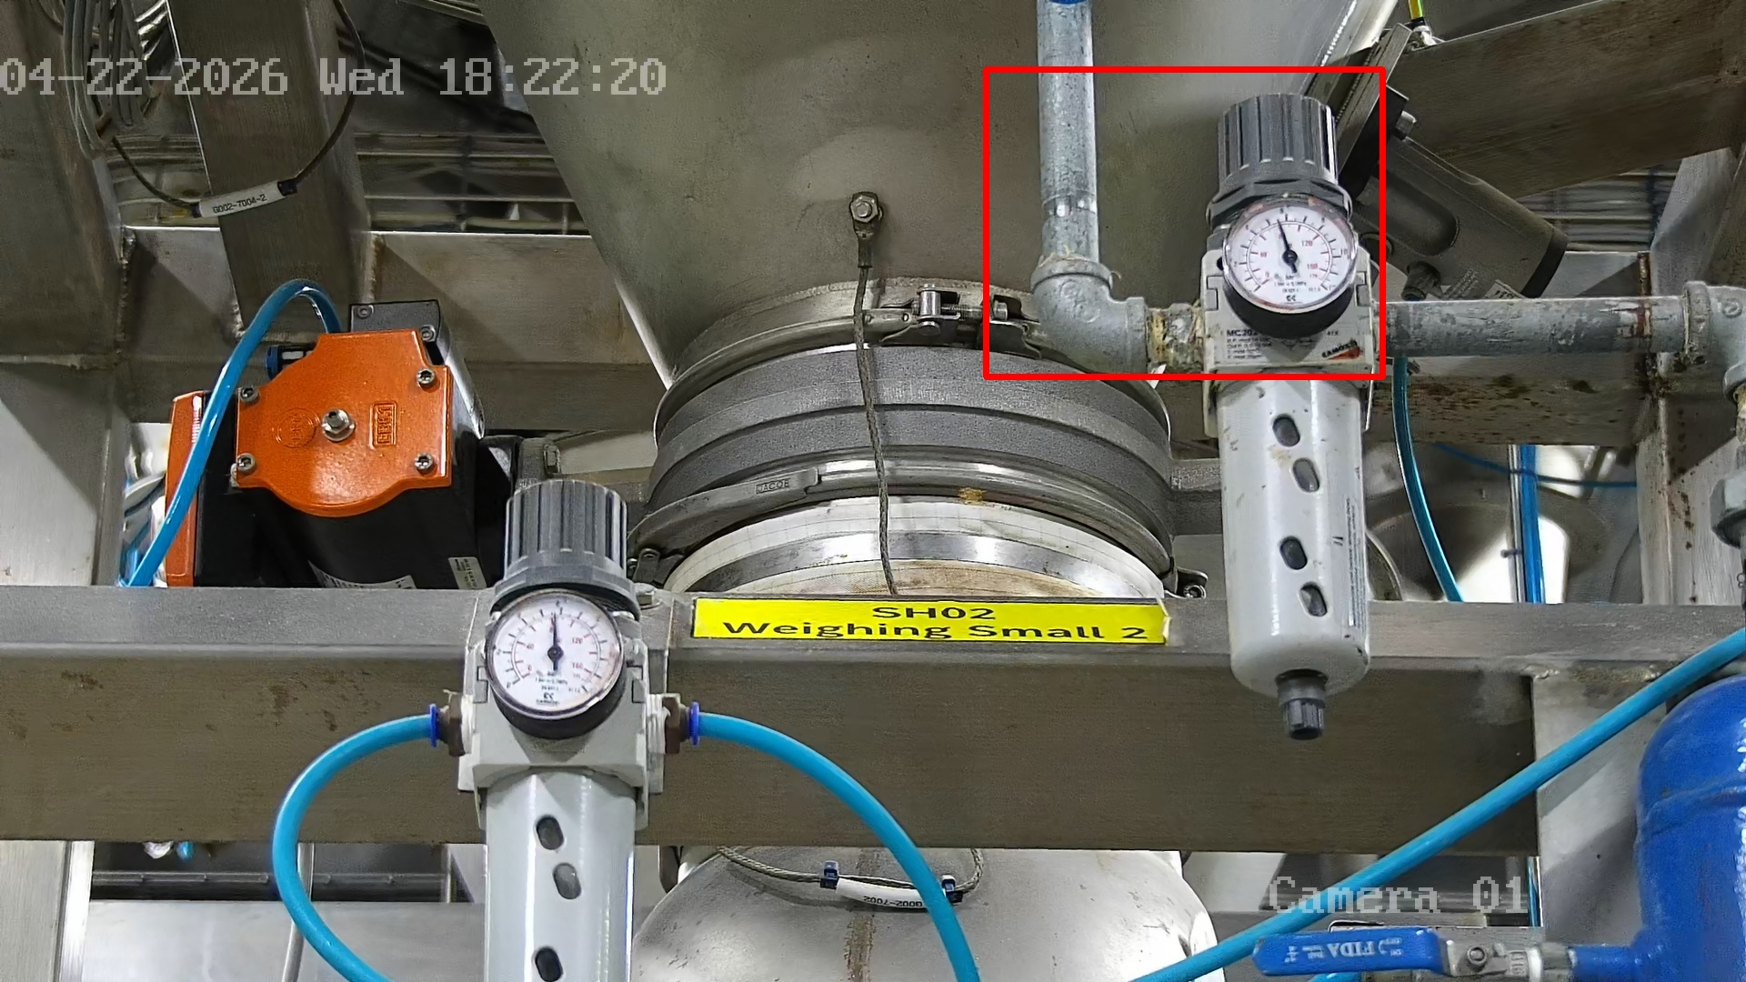
Sample Inspection Results
inspection details
Inspection Index:9
Mission Id:268
Detection Status:False
Notification Level:Critical

Asset Inspection(asset-11)
The vision system identified an anomaly in the storage area, detecting that certain equipment was missing or not present on the designated storage rack.
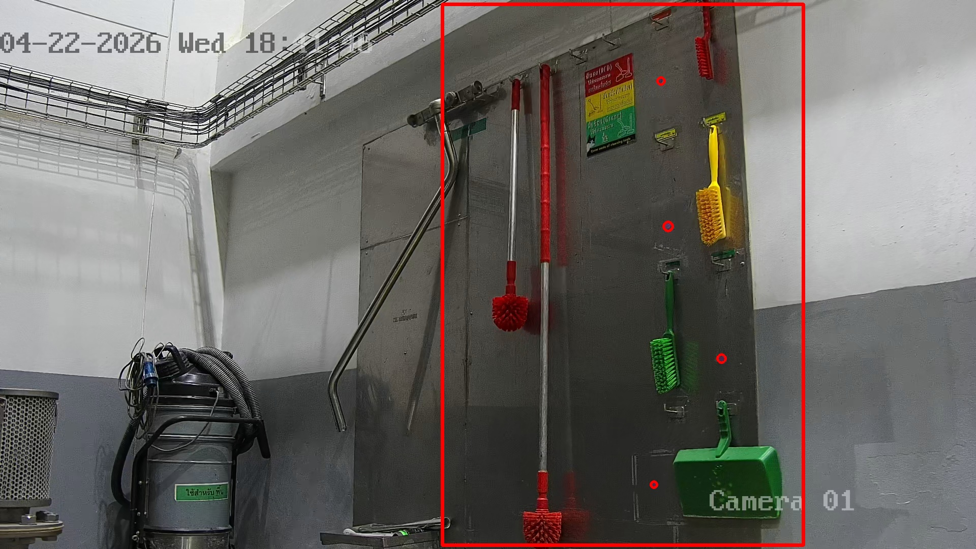
Sample Inspection Results
inspection details
Inspection Index:24
Mission Id:269
Detection Status:False
Notification Level:Critical

Vibration Inspection(Vibration-32)
The system analyzed acoustic vibration patterns to assess the motor's operational condition. The results indicate that the motor is functioning normally with no signs of mechanical damage.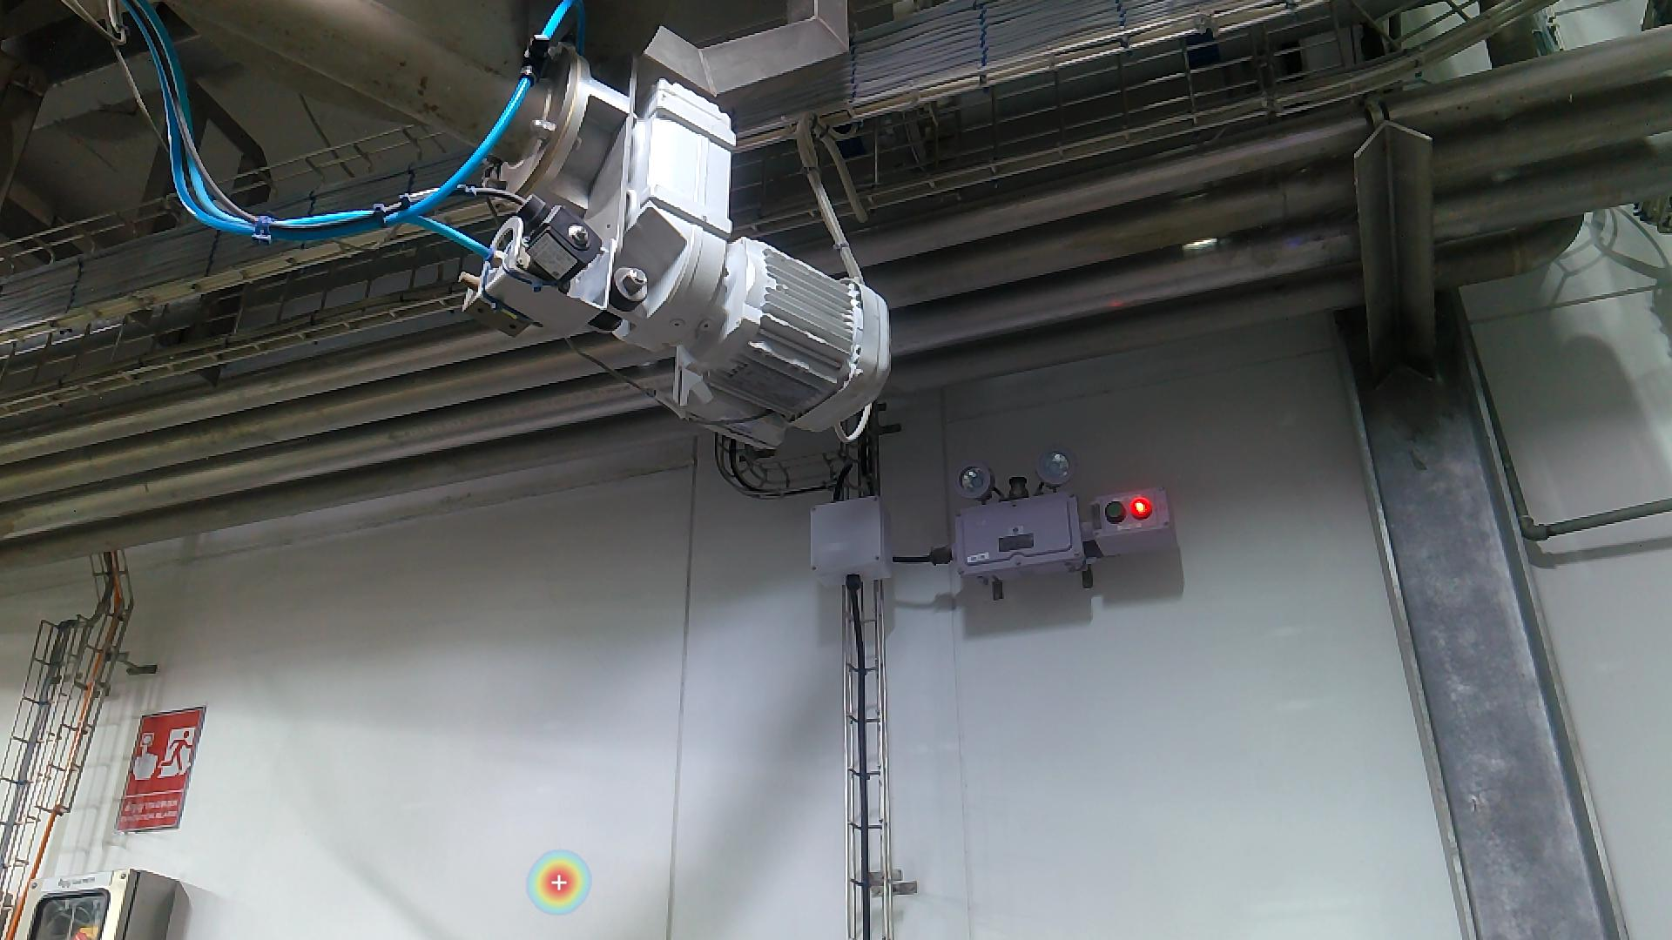
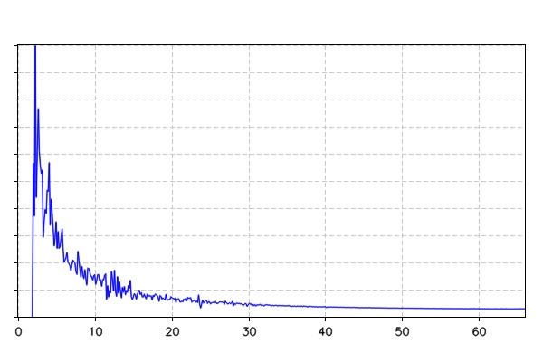
Sample Inspection Results
inspection details
Inspection Index:11
Mission Id:269
Kurtosis:2.98
Peak Factor:4.15
Notification Level:Pass

